Stories: YES
Stories from Main Street: Youth Engagement and Skill-building
A Complementary Education Program for Museum on Main Street Exhibitions
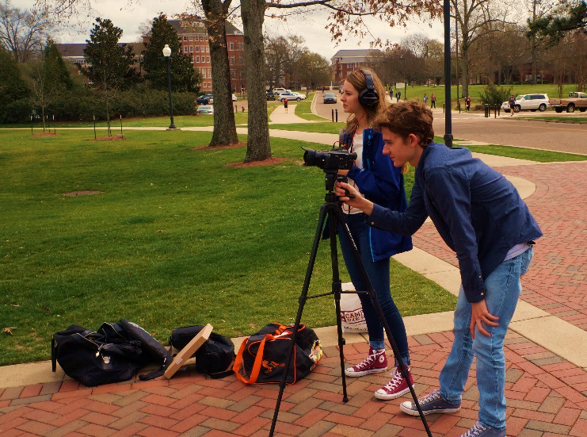
WHO: Host venues guide youth projects based on the themes of MoMS traveling exhibition.
WHAT: Stories: YES provides digital technology and critical thinking skills for kids in your community to explore local history and gain professional expertise by creating online stories (3-5 minutes each).
WHEN: The timeline is entirely independent from your exhibition
July 2019—Proposals to participate are submitted by venues and MoMS selects partners
August 2019—MoMS applies for funding with support of selected exhibition host venues
September 2019—Projects are planned and training begins with youth
January 2020—Funding is awarded for technology purchases
WHERE: Digital stories are made by kids in your community and become part of Smithsonian’s Stories from Main Street online collection, highlighting youth talent and relevance of local history.
WHY: New technology enables your organization to deepen the relationship with youth and local educators because you support the acquisition of professional 21st century and real world skills.
HOW: Young people conduct research and interviews, make recordings, and produce digital stories relevant to your MoMS exhibition by using professional equipment.
Stories: YES makes your organization a technology hub, creating a connection to kids in a way they can relate. Kids use the experience for college applications or to build resumes, while venues enhance local partnerships and acquire valuable equipment.
Projects may be multi-media websites or short videos, as long as they support youth to explore the community from their perspective. (See Examples)
The program can be extracurricular or a school collaboration. Age range and number of participants can vary, usually depending on how many kids your organization can assist with research, interviews, writing, and editing their digital stories.
You can blend support and expertise from as many individuals and organizations as you’d like—more community input and collaboration make the projects stronger. Residents, businesses, and local organizations are assets for this inspiring collaboration with kids, while also building and strengthening your impact within your community. See the Project Proposal for more details on planning your Stories: YES program.
PROJECT EXAMPLES – Stories: YES

Iowa 2018, exhibition Hometown Teams
In 2012, the Mount Vernon High School Boys Basketball Mustangs won the State Championship. Players and the Coach recall the difficulties and successes. (7:23 video)
https://museumonmainstreet.org/content/unforgettable-season-2012-state-champions-boys-basketball

Arkansas, 2018, exhibition The Way We Worked
Buffalo Island possesses some of the most fertile soil in the world. Originally surrounded by swamps, this ArcGIS Story Map explores how the area became farmland. (website)
https://museumonmainstreet.org/content/buffalo-island-swamp-farmland

Maryland, 2017, exhibition The Way We Worked
Ivan Lufriu, the last miller in Carroll County, Maryland, discusses the process of milling, and how the historic Union Mills Homestead was established in 1797 by the Shriver family. (3:47 video)
https://museumonmainstreet.org/content/union-mills-homestead-and-milling-maryland

Illinois, 2016, exhibition Water/Ways
Sisters Sue Gerhart and Rose Gerhart Robison recall the flood in 1943 when their family evacuated in the middle of the night. (5:04 video)
https://museumonmainstreet.org/content/lawrence-county-floods-gerhart-sisters

Illinois, 2016, exhibition Water/Ways
Three young people worked together to explore water issues in their community. (4:26 video)
https://museumonmainstreet.org/content/pollution-our-waterways-central-illinois

Stories: YES Proposal Guidelines and Advice
To apply to participate in Stories: YES, please use the Project Proposal form below to provide us with information on your vision and goals for your proposed youth stories. Proposals help MoMS select communities who will receive stipends for projects. Some questions to consider as you develop your proposal are listed below. Shannon Sullivan, Museum on Main Street’s Stories: YES Program Coordinator, is happy to answer questions about this opportunity: sullivans@si.edu; 202.633.5343
- What are your goals for working with local youth? What will be the benefits to your organization?
  - How can storytelling improve your organization’s outreach to youth?
  - Are there existing history or technology projects in your community or is there a need for a new one? Describe.
  - Partnerships are a hallmark of this program. Can you collaborate with schools and/or teachers? Alternatively, is it possible to collaborate with youth organizations or other extracurricular programs (e.g. Future Farmers of America or library youth programs)?
- Describe how your organization will make historical and other cultural resources available to youth for completing their projects.
  - Youth engage with your organization and partners through research and primary sources (i.e. interviewing locals, finding images, searching local libraries or archives). What resources will you provide to help youth develop their stories?
  - Can your partners provide youth access to other cultural resources?
- What type of project would you like youth to create (e.g. video or website)? What local history subjects or themes would you ask them to explore? Remember that youth should lead the projects.
  - Successful projects highlight local history and relate to the themes of your MoMS exhibition. How will these topics stimulate community reflection on local history?
  - What are your organization’s goals for the final project? How will you share the finished stories with your community (i.e. display them or hold a premiere celebration)?
  - Can you combine any local exhibition programming with youth activities?
- Describe the personnel that would be involved in your project.
  - A Project Manager should be a representative of your organization (staff or volunteer) while a Technology Adviser may be external. Do you know people who fit these roles or can you partner with an organization or business that can help? These roles could be filled by educators or teachers depending on their area of expertise and availability.
  - If already identified, provide specific names, job titles and a description of the roles.
- Describe the logistics of your planned program.
  - What town, county or other defined area will be the basis for your program? Will youth from multiple schools or locations participate? Will travel be required for youth to have access to research, interviews and technology?
  - Although equipment is purchased in the winter, what activities can you begin earlier in the fall to prepare youth for the recording and editing process? You may use MoMS online tools and training modules or develop your own workshop plan. Please describe.
- Describe how new equipment (video cameras, microphones, lighting kit, etc.) and software could benefit your organization and local youth beyond this project.
  - How might you continue to use this technology and pursue other partnerships to expand your community services and programming?
Stories: YES Project Proposal
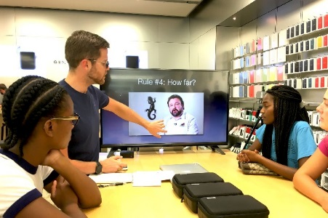
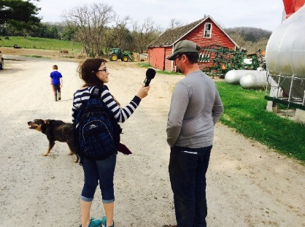
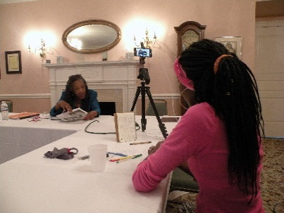

Organization/State:
Contact Person Name and Email:
Name of Exhibition and Dates:
- What are your goals for working with local youth? What will be the benefits to your organization? (please limit to 200 words)
- Describe how your organization will make historical and other cultural resources available to youth for completing their projects.
- What local history or themes would you ask youth to explore? How will these topics engage youth and stimulate community reflection on local history?
- Describe the personnel that would be involved in your project.
- Describe the logistics of your planned program.
- Describe how new equipment (video cameras, microphones, lighting kit, etc.) and software could benefit your organization and local youth beyond this project.

Please submit this application to Shannon Sullivan, Stories: YES Program Coordinator at sullivans@si.edu. DEADLINE for Applicants, Friday June 14, 2019

