Stories: YES
Stories from Main Street: Youth Engagement and Skill-building
A Complementary Education Program for Museum on Main Street Exhibitions
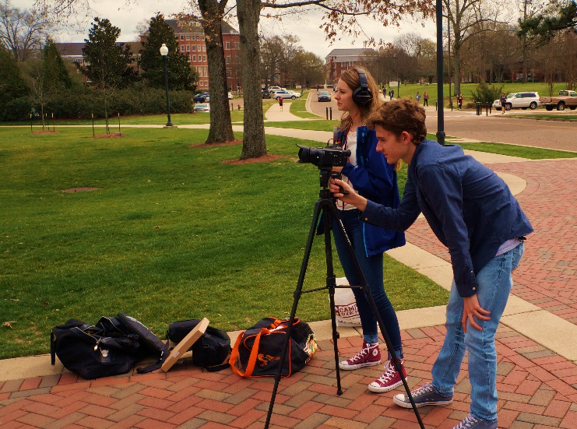
WHO: Venues guide youth projects based on the themes of MoMS traveling exhibition.
WHAT: Stories: YES provides digital technology and skills for kids in your community to explore local history and gain professional expertise by creating online stories (3-5 minutes each).
WHEN: The timeline is entirely independent from your exhibition
May 2018—Proposals to participate are submitted by venues and MoMS selects partners
July 2018—MoMS applies for financial support in collaboration with selected venue partners
September 2018—Projects are planned and training begins with youth
December 2018—Funding is awarded for technology purchases
WHERE: Digital stories are made by kids in your community and become part of Smithsonian’s Stories from Main Street online collection, highlighting youth talent and relevance of local history.
WHY: New technology enables your organization to deepen the relationship with youth and local educators because you support the acquisition of professional 21st century and real world skills.
HOW: Young people conduct research and interviews, make recordings, and produce digital stories relevant to your MoMS exhibition by using professional equipment.
Stories: YES makes your organization a technology hub, creating a connection to kids in a way they can relate. Kids use the experience for college applications or to build resumes, while venues enhance local partnerships and acquire valuable equipment.
Projects may be multi-media websites or short videos, as long as they support youth to explore the community from their perspective. (See Examples)
The program can be extracurricular or a school collaboration. Age range and number of participants can vary, usually depending on how many kids your organization can assist with research, interviews, writing, and editing their digital stories.
You can blend support and expertise from as many individuals and organizations as you’d like—more community input and collaboration make the projects stronger. Residents, businesses, and local organizations are assets for this inspiring collaboration with kids, while also building and strengthening your impact within your community. See the Project Proposal for more details on planning your Stories: YES program.
PROJECT EXAMPLES – Stories: YES

Maryland, 2017, exhibition The Way We Worked
Ivan Lufriu, the last miller in Carroll County, Maryland, discusses the process of milling, and how the historic Union Mills Homestead was established in 1797 by the Shriver family. (3:47)
https://museumonmainstreet.org/content/union-mills-homestead-and-milling-maryland
Evidence of research and preparation for the interview; engagement with subject
- Ability to search for and synthesize information (networking)
- Ability to refine project topic and select topic that is relevant to exhibition and community
- Ability to evaluate the reliability and credibility of information sources (judgment; core curriculum)
- Ability to craft questions well-suited to the experience and perspective of the interviewee
Arkansas, 2017, exhibition Hometown Teams
School sports are explored over decades in Cross County, Arkansas through this GIS Story Map website.
http://arcg.is/2mbYOKm
Evidence of appropriate technology for both topic and project type (e.g. video or audio)
- Strategic use of multimedia like visual displays and text to enhance understanding of the message
- Use of technology to link to other information and display information flexibly and dynamically
- Ability to meaningfully sample, edit and remix media content (appropriation)
- Preparation of sound, lighting and interview space for a polished recording (audio or video)
Illinois, 2016, exhibition Water/Ways:
Three young people worked together to explore water issues in their community. (4:26)
https://museumonmainstreet.org/content/pollution-our-waterways-central-illinois
Evidence of context and shaping a narrative message
- Ability to express ideas clearly and persuasively (core curriculum)
- Ability to use evidence in support of an idea
- Ability to tell a story with an introduction, middle and conclusion
- Ability to match style of presentation and development of the story to the intended audience
- Ability to edit based on empathic understanding and meaning from the perspective of the interviewee
Texas, 2014, exhibition Journey Stories:
The website Full Circle tells the story of a brother and sister, from growing up in the segregated South, moving away and then returning home once again.
http://62620044.nhd.weebly.com/
Evidence of linking local history to larger narrative of American history
- Evidence of knowledge of local history
- Ability to tie local stories and events with larger topics like immigration; work; etc.
- Has value as a research or educational tool for others.
Minnesota, 2016, exhibition Water/Ways:
Youth explored contemporary issues related to natural resources and agriculture, inspiring further investigation of the community’s changing way of life. This video was created by an 8th grader. (17:56)
https://museumonmainstreet.org/content/small-town-big-changes
Evidence of collaboration and interaction with people, organizations or businesses in community
- Participation in a range of conversations and collaborations with variety community members, representing and building on others’ ideas, including community leaders and organizational leaders
- Ability to pool knowledge and compare notes with others toward a common goal (collective intelligence) or seek information from key sources and individuals
- Ability to use local resources like a historical society, museum or library.
Stories: YES Proposal Guidelines and Advice
To apply to participate in Stories: YES, please use the Project Proposal form below to provide us with information on your vision and goals for your proposed youth stories. Proposals help MoMS select communities who will receive stipends for projects. Some questions to consider as you develop your proposal are listed below. Shannon Sullivan, Museum on Main Street’s Stories: YES Program Coordinator, is happy to answer questions about this opportunity: sullivans@si.edu; 202.633.5343
- What are your goals for working with local youth? What are the benefits for your organization?
  - How can your organization’s outreach to youth be improved through Stories: YES?
  - Is there a need for public history projects in your community?
  - Collaboration with other organizations is a hallmark of this program. Can you collaborate with schools and/or teachers? Is it possible to collaborate with existing youth organizations or extracurricular programs (e.g. Future Farmers of America or local Boys’ and Girls’ Clubs) or develop a new one?
- Describe how your organization will make historical and other cultural resources available to youth for completing their projects.
  - This program increases youth engagement with your organization through research and primary sources (i.e. interviewing locals, investigating images, searching local libraries or archives). What resources will you provide to help youth develop their stories?
  - How will you provide youth access to cultural resources and interviewees?
- What local history or themes would you ask youth to explore? How will these topics engage youth and stimulate community reflection on local history?
  - Successful youth projects highlight local history and relate to the themes of your MoMS exhibition, connecting youth to their own local identity and demonstrating how national themes impact the community.
  - Remember that young people should be the developers of their own projects and draw their own conclusions based on their research. How will you work with youth to determine themes that sustain their interests and the goals of your organization?
  - Can you combine any exhibition programs with youth activities (depends on when you host your exhibition)?
- Describe the personnel that would be involved in your project.
  - A Project Manager should be a representative of your organization (staff or volunteer) while a Technology Adviser may be external. One of these roles could be filled by an educator depending on their area of expertise and availability.
  - How will you identify your local Project Manager, Technology Adviser and Educators? If already identified, provide their names, job title and why they are a good fit.
- Describe the logistics of your planned program.
  - Will you involve youth from multiple communities? What town, county or other geographical area will provide the setting for youth research and projects?
  - Consider whether transportation is needed for research, interviews and equipment or if everything can be made available at your facility.
- Describe how new equipment (cameras, camcorders, scanners, etc.) or software purchased with the stipend could benefit your organization and local youth beyond this project.
  - How might you duplicate or continue your work with local youth into the future?
Stories: YES Project Proposal
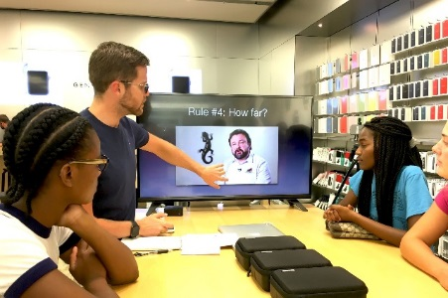
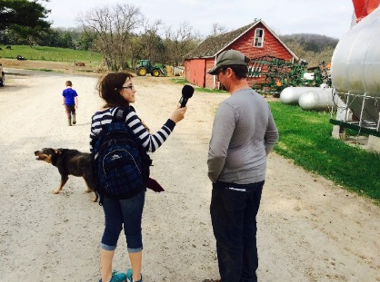
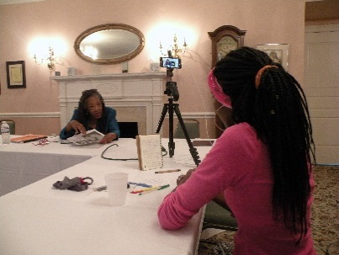

Organization/Town:
Contact Person Name and Email:
Name of Exhibition and Dates:
- What are your goals for working with local youth? What would be the primary benefits for your organization? (please limit to 200 words)
- Describe how your organization will make historical and other cultural resources available to youth for completing their projects.
- What stories or themes would you ask youth to explore? How will those stories engage students and stimulate community reflection on local history?
- Describe the personnel that would be involved in your project.
- Describe the logistics of your planned program.
- Describe how new equipment (cameras, camcorders, scanners, etc.) or software purchased with the stipend could benefit your organization and local youth beyond this project.

Please submit this application to Shannon Sullivan, Stories: YES Program Coordinator at sullivans@si.edu. DEADLINE Friday, May 21, 2018

